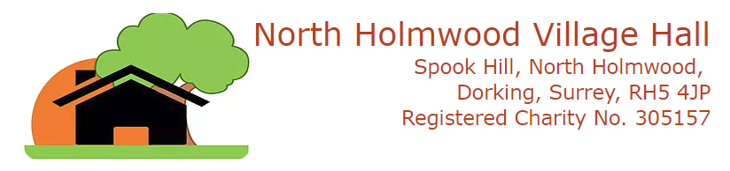

web: www.north-holmwood-village-hall.org.uk

PAYMENTS
Updated: 10th January 2020

Payments for the hire of North Holmwood Village Hall can be undertaken in the following ways:

Bank to Bank Transfer
- Barclays Bank Sort Code: 20-23-97
- Account No. 70052736
- Account Name: North Holmwood Village Hall
- Note your organisation name on the transaction to help us identify your payment

Cheque
- payable to North Holmwood Village Hall

Cash
- only if there is no other option please

Notes to Regular (weekly) hirers
- Payments must be made on a monthly basis (unless agreed otherwise with the Halls Manager).
- All payments must be accompanied by a specific list of dates of hire to which the payment relates - please e-mail or post a written payment breakdown to the Halls Manager bookings@north-holmwood-village-hall.org.uk
- Please do not just put e.g. 'Spring term' or no. of sessions as we need to reconcile this to the diary

Disputes

If you have any dispute about payments, please contact the Treasurer or Chairman (see below):

Contacts

Halls Manager | Treasurer | Chairman
Linda Foskett | Debbie Steenhuis | John Foskett
Tel: 07712 224681 | Tel: 01403 254945 | Tel: 01306 883808
Address:  c/o North Holmwood Village Hall  Spook Hill  North Holmwood  Dorking  Surrey  RH5 4JP | Address:  c/o North Holmwood Village Hall  Spook Hill  North Holmwood  Dorking  Surrey  RH5 4JP | Address:  c/o North Holmwood Village Hall  Spook Hill  North Holmwood  Dorking  Surrey  RH5 4JP
e-Mail:  bookings@north-holmwood-village-hall.org.uk | e-Mail:  treasurer@north-holmwood-village-hall.org.uk | e-Mail:  chairman@north-holmwood-village-hall.org.uk

