FIRE NOTICE (Part 1 of 2)
Note: The Village Hall complex has a fire detection and alarm system in place
Should you discover a fire, suspect a fire or hear the fire alarm:
Warn people in the vicinity of the fire.
Give necessary assistance to other people to ensure their safety.
Walk to the nearest available EXIT then proceed to the assembly point.

Contact the Fire Service immediately on 999
(North Holmwood Village Hall has no public phone, so you will need to use your own mobile phone)
When the Fire Service Operator replies give clear details as follows:
Fire at North Holmwood Village Hall
Spook Hill, North Holmwood, Dorking, RH5 4JP
Act on the instructions given by the operator.
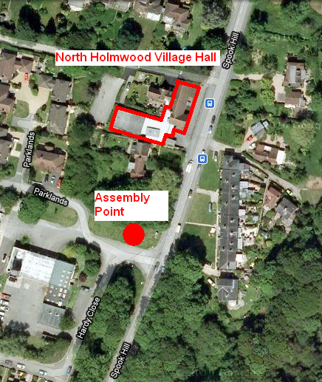
Assembly Point:
The grassed area near the Fire Station to the south of the Village Hall

Act calmly
Close all doors
Do not take personal risk
Leave the building
Do not attempt to retrieve personal belongings

The responsible person in charge should:

- Not allow people to re-enter the building
- Check and note who is present at the Assembly Point and who is missing
- On arrival of the Fire Service inform the Emergency Services that all are present or for anyone missing, their last known location
FIRE NOTICE (Part 2 of 2)
Sculptor’s Hall
Note: The Village Hall complex has 3 venues. More than one of these may be in use at any point in time.
The diagram below identifies the 3 venues.
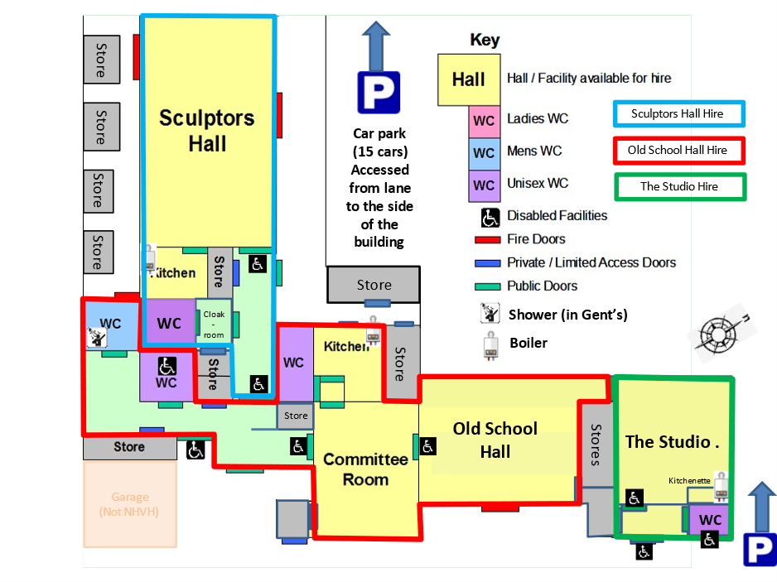
The following external doors must be unbolted & unlocked:
- Side Entrance to the corridor
- Fire doors on the North & South sides of the hall
Additionally, please note:
- The link door between the Sculptor’s Hall and the Main Entrance area may be locked to keep these two venues separate.

