Conditions of HIRE - ONE OFF HIRES
Last Updated: 14th July 2022

North Holmwood Village Hall has 3 venues –Sculptor’s Hall, Old School Hall / Committee Room and The Studio.

Normally, the Sculptor’s Hall and Old School hall / Committee Room share a communal area comprising the Sculptor’s Hall corridor, Cloakroom, Ladies Toilets, Main Front Entrance, Disabled Entrance, Disabled Toilet and Gent’s Toilet.

The door between the Sculptor’s Hall corridor and the Main Front Entrance area may be locked to isolate the Sculptor’s Hall and Old School Hall / Committee Room from each other. Hirers can request this door be locked for reasons of security, a need for quietness in a venue etc. North Holmwood Village Hall may choose to lock this door for certain events, reasons of security etc.

When this door is locked, there is no internal through route between the rear of the premises and the Old School Hall / Committee Room areas. The Ladies toilet will then operate as Unisex for use only by Sculptors Hall attendees.

The Studio is normally hired as an independent venue with its own entrance & toilet. The door between it and the Old School Hall is normally locked. Hirers may hire The Studio with the Old School Hall / Committee Room, in which case this door will be unlocked.
.
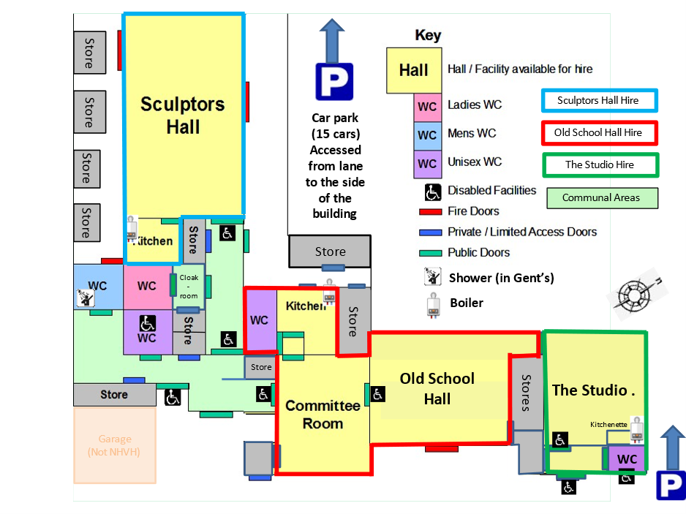

.

General Information for Hirers following Covid-19
- Hirers must make themselves aware of the areas of the premises open to them and those which are not.
- Hirers and attendees must strictly adhere to booked start and finish times to avoid overlap with the next hirer.
- Sanitisation stations are available in each venue.
- Windows and Emergency Exit Doors may be opened to provide additional ventilation.
- Hirers must ensure that they clean all areas of the facility they use thoroughly at the end of their hire to minimize any possibility of infection being passed on to a subsequent hirer.
- On vacating the premises, hirers are responsible for locking up the venue they have used and all communal areas open to them at the time.
- Hirers are themselves responsible for implementation of UK Government Rules, Guidelines and Best Practices associated with their activity.

Measures in place to assist in minimizing the spread of viruses:
- Professional cleaning of the premises (provided by Ideal Touch Cleaning) occurs very early morning every day for a venue and the communal areas when there is a booked hire, however, additional cleaning (as described above) must take place at the end of a session (and potentially during a session). This will be required to be undertaken by the hirer.
  - North Holmwood Village Hall schedules a minimum of ½ hour gap between hires.
- Hirers (and their attendees) are requested not to arrive at the premises before the start of the hire period and to have left the premises by the end of the hire period – sufficient time must be included in the hire period for the hirer to clean and vacate the premises leaving it ready for a subsequent hirer.

Responsibilities of the hirer:
- The hirer is responsible for all loss of, or damage to, North Holmwood Village Hall, or its contents, occurring during the period of hire or at any other time during the hirer’s care.
- The period of hire, as agreed with the Halls Manager, must be adhered to. Any extension of hire not previously agreed may be charged for.
- The hirer must read the ‘Fire Notice’ & ‘Safety & Security’ documents prior to period of hire.
- If the named hirer is not present for the duration of the period of hire, they must ensure a responsible adult is present throughout, and that they have also read the ‘Conditions of Hire’, ‘Fire Notice’ & ‘Safety & Security’ documents provided to by the Halls Manager.
- The hirer is responsible for ensuring that all the Conditions of Hire (stated below) are strictly adhered to.

Hirers must note and abide by the following:

Access  Restrictions | - The hirer must ensure that attendees are restricted to areas of the building included within the hire agreement, and be aware that, unless agreed otherwise, the front entrance area, main toilets, corridor areas and car park are communal and may also be in use by hirers of other parts of the premises and / or contractors undertaking facilities maintenance:  - Children must NOT be allowed to play in the entrance area or corridor areas.  - When waiting, children must remain under parental supervision in the designated locations.
Cleaning | - Upon completion of the period of hire, the village hall must be left in a clean condition:  - The hirer is responsible for cleaning ALL areas used during the hire (floors, kitchen, tables, etc)  - The hirer is responsible for providing their own cleaning materials.  - Brooms and other cleaning utensils are available in the cupboard in the entrance lobby and must be returned to the cupboard after use.  - Mops have been provided for floor cleaning and are located in the kitchen.
Curtains | - The Sculptors’ Hall has electrically operated curtains protecting mirrors at the end of the hall.  - Nothing may be pinned, taped or hung on any curtains at any time.
Doors & Access | - All exits are to be kept clear of obstruction.  - Entrance doors and fire exit doors must be unlocked and unbolted when the village hall is occupied.
Electrical  Equipment | - It is incumbent on hirers to ensure that any equipment they use on North Holmwood Village Hall premises is PAT Tested and satisfies government safety regulations and recommendations.
Fire | - The hirer must ensure attendees are aware of the emergency exits and the location of fire extinguishers and be themselves familiar with the Fire Notice.  - IN THE EVENT OF AN INCIDENT THE SAFETY AND SECURITY OF PEOPLE IS THE HIRER’S RESPONSIBILITY.
Floors | - To protect the floors, stiletto heeled shoes may not be worn inside the premises at any time. (High heeled purpose manufactured Ballroom & Latin American dance shoes may be worn.)
Heating | - There are two separate central heating systems running from combi boilers in  - The Sculptor's Hall Kitchen (for the Sculptor’s Hall corridor & toilets)  - Committee Room Kitchen (for the Old School Hall, Committee Room, The Studio, entrance area, gents, main disabled toilet)  - The central heating is set to about 18.5 deg C.A thermostatic monitor/controller is located on the wall in the Committee Room and Sculptor’s Hall to control the overall room temperature. The heating is timed to coincide with regular bookings.  - Should the heating not be right for your hire you can take control of it in the following ways:  - Increase / decrease the thermostats on the individual radiators (not available in the Old School Hall / Committee Room)  - Increase / decrease the wall thermostats (for The Studio, seek access to the Old School Hall / Committee Room)  - Toggle the timer inside the boiler pull down cover to 'on all the time' (for The Studio, seek access to the Old School hall / Committee Room)  - DO NOT TOUCH THE BOILER TEMPERATURE CONTROL KNOB
Hot Water | - There are 3 separate hot water systems in  - The Sculptor’s Hall (for the Sculptor’s Hall and toilets)  - The Committee Room Kitchen (for the Committee Room Kitchen & toilet)  - The North Entrance disabled WC (for this WC and The Studio kitchenette)
Keys | - All keys remain the property of North Holmwood Village Hall.  - Key holders must keep any keys in their charge in a safe place.  - Keys must not be handed to another party without agreement of the Halls Manager  - Keys must not be duplicated without the agreement of the Halls Manager  - The hirer is only permitted to use the keys for the periods of hire.  - On ceasing regular hires, all keys must be returned as agreed.  - Loss of keys or failure to return keys may result in a charge.
Kitchens /  Kitchenette | - The kitchens are to be used solely as kitchens and not for any other purpose.  - They must NOT be used as changing rooms or cloakrooms.  - Children must be supervised in the kitchen / Kitchenette and not left unattended at any time.  - Any items of crockery used during hire must be washed, dried and put away.  - All surfaces must be wiped clean.  - The hirer must ensure taps and the oven are turned off before leaving.
Accident, Loss  or Damage | - The hirer is responsible for any loss or damage to North Holmwood Village Hall, or its contents, that occurs during the hirer’s care.  - If any damage requires immediate attention, the hirer must contact the Halls Manager on 07712 224681.  - The hirer must report any accident, loss or damage to the Halls Manager as soon as possible and complete an accident report form (located in the file in the kitchen).  - The hirer will be invoiced for any loss or damage caused during their hire and must pay said invoice within 14 days to avoid any further action.
Noise &  Nuisance | - The Village Hall is in a residential area and care must be taken to avoid noise nuisance.  - It is regretted that live or recorded music played at high volume through speakers is not permitted.  - The double fire doors on the south side (left side as you enter) of the Sculptors Hall must not be opened except in an emergency.  - Music played in the village hall must be kept at a reduced volume after 10:00pm.
Parking | - There is a car park at the rear of the building for users of the village hall. Vehicles are parked at owner’s risk.  - When parking in the rear car park please ensure that cars are parked in the marked spaces  - It is very important that the following rules are obeyed:  - The front entrance must not be obstructed.  - Free passage must be maintained at all times from the garage at the front of the building.  - Cars must not be parked in the lane to the side of the village hall.  - Cars must not be parked or wait on Spook Hill on the village hall side of the road.  - Always ensure that emergency vehicles have clear access.
Putting Away at the end of the hire | - For the Old School Hall / Committee Room, chairs must be in stacks of 6, seat facing the wall at the back of the Committee Room  - For the Sculptor’s Hall, chairs must be in the cloak room, not in front of any coat pegs.  - For The Studio, chairs must be stacked in the corner opposite the door to the Old School Hall.  - All tables, or other equipment taken from a storeroom, must be returned to the same place from which they were taken (providing this does not interrupt another hirer.)  - If helium balloons are lost in the high ceiling, the hirer must contact the Halls Manager.
Rubbish | - ALL RUBBISH MUST BE REMOVED FROM THE PREMISES AND DISPOSED OF BY THE HIRER.  - Please do not use the bins at the hall.
Security | - The hirer should assess the risk of persons forcing entry or public disturbance and take all possible action with the bounds of the law, to refuse entry. Help should be sought if the problem persists.
Smoking | - No smoking (including e-cigarette) is allowed within or in close proximity to the Village Hall.
Telephone / Wifi | - There is no public telephone located on the premises, however free wifi is available.  - It is incumbent on hirers to have a mobile phone they can use in the event of an emergency.
Usage | - The village hall must not be used for any purpose other than that agreed in the Hire Agreement.
Vacating the premises | - Upon vacating the premises the hirer must ensure all doors and windows are secured, lights and taps turned off and heating returned to original settings in the venue(s) hired.

The hire will at all times be subject to the authority of the Halls Manager or other members of the Council of Management in all matters relating to the use of the Halls.

